**BRAIN TUMOUR IDENTIFICATION USING CONVOLUTIONAL NEURAL NETWORK**

***A project report submitted in partial fulfilment of the requirements for the award of the degree of***

**BACHELOR OF TECHNOLOGY IN**

**COMPUTER SCIENCE ENGINEERING**

***Submitted by***

**J. G. SIVA SAI (316126510085) ROHITHA. K (316126510108) S. DEEPIKA (316126510116) M. N. SINDHURI (316126510098)**

**Under the guidance of P. Naga Srinivasu Assistant Professor**



**DEPARTMENT OF COMPUTER SCIENCE AND ENGINEERING**

ANIL NEERUKONDA INSTITUTE OF TECHNOLOGY AND SCIENCES (UGC AUTONOMOUS)

(*Permanently Affiliated to AU, Approved by AICTE and Accredited by NBA & NAAC with ‘A’ Grade*)

Sangivalasa, Bheemili Mandal, Visakhapatnam Dist. (A.P)

2019 – 2020

**DEPARTMENT OF COMPUTER SCIENCE AND ENGINEERING**

**ANIL NEERUKONDA INSTITUTE OF TECHNOLOGY AND SCIENCES (UGC AUTONOMOUS)**

**(*Permanently Affiliated to AU, Approved by AICTE and Accredited by NBA & NAAC with ‘A’ Grade*)**

**Sangivalasa, Bheemili Mandal, Visakhapatnam Dist. (A.P)**

**2019 - 2020**



**BONAFIDE CERTIFICATE**

This is to certify that the project report entitled **“BRAIN TUMOUR IDENTIFICATION USING CONVOLUTIONAL NEURAL NETWORK”** submitted by **J. G. SIVA SAI (316126510085), ROHITHA. K (316126510108), S. DEEPIKA (316126510116), M. N. SINDHURI (316126510098)** in partial fulfilment of the requirements for the award of the degree of **Bachelor of Technology** in **Computer Science Engineering** of Anil Neerukonda Institute of Technology and Sciences (A), Visakhapatnam is a record of bonafide work carried out under my guidance and supervision.

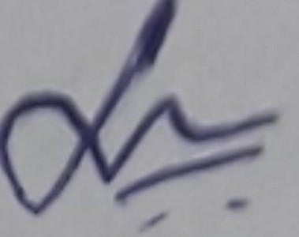

**Project Guide Head of the Department**

**P. Naga Srinivasu Dr. R. Sivaranjani** Assistant Professor Professor Department of CSE Department of CSE ANITS ANITS

**DECLARATION**

We, **J. G. SIVA SAI (316126510085), ROHITHA. K (316126510108), S. DEEPIKA (316126510116), M. N. SINDHURI (316126510098)** , of Fourth Year B.Tech., in the Department of Computer Science and Engineering from ANITS, Visakhapatnam, hereby declare that the project work entitled **“BRAIN TUMOUR IDENTIFICATION USING CONVOLUTIONAL NEURAL NETWORK”** is carried out by us and submitted in partial fulfilment of the requirements for the award of **Bachelor of Technology in Computer Science Engineering** , under Anil Neerukonda Institute of Technology & Sciences(A) during the academic year 2016-2020 and has not been submitted to any other university for the award of any kind of degree.

|  |  |
| --- | --- |
| **J. G. SIVA SAI** | **316126510085** |
| **ROHITHA. K** | **316126510108** |
| **S. DEEPIKA** | **316126510116** |
| **M. N. SINDHURI** | **316126510098** |

**ACKNOWLEDGEMENT**

We would like to express our deep gratitude to our project guide, **Mr. P. Naga Srinivasu**, Assistant Professor, Department of Computer Science and Engineering, ANITS, for his guidance with unsurpassed knowledge and immense encouragement. We are grateful to **Dr. R. Sivaranjani**, Head of the Department, Computer Science and Engineering, for providing us with the required facilities for the completion of the project work.

We are very much thankful to the **Principal and Management, ANITS, Sangivalasa,** for their encouragement and cooperation to carry out this work.

We also thank our Project Coordinator **Mrs. K. S. Deepthi**, for her support and encouragement. We express our thanks to all **teaching faculty** of Department of CSE, whose suggestions during reviews helped us in accomplishment of our project. We would like to thank **Mrs. Udaya Lakshmi** of the Department of CSE, for providing us the lab resources in accomplishment of our project.

We would like to thank our parents, friends, and classmates for their encouragement throughout our project period. At last but not the least, we thank everyone for supporting us directly or indirectly in completing this project successfully.

|  |  |
| --- | --- |
| **J. G. SIVA SAI** | **316126510085** |
| **ROHITHA. K** | **316126510108** |
| **S. DEEPIKA** | **316126510116** |
| **M. N. SINDHURI** | **316126510098** |

|  |  |  |
| --- | --- | --- |
| **Figure No.** | **Description of Figures** | **Page No.** |
| Fig 3.1 | Location of tumors in eight different images | 17 |
| Fig 4.1 | Module Division | 19 |
| Fig 5.1 | Input Image | 32 |
| Fig 5.2 | Gray-scale Image | 33 |
| Fig 5.3 | Filtered Image | 33 |
| Fig 5.4 | Image after edge detection | 34 |
| Fig 5.5 | Thresholded and Binary Image | 35 |
| Fig 5.6 | Morphological Image | 35 |
| Fig 5.7 | Dilated Image | 36 |
| Fig 5.8 | Training data history | 37 |
| Fig 5.9 | Represents the performance analysis of CNN | 45 |
| Fig 5.10 | Represents the performance of proposed CNN | 46 |

**LIST OF TABLES:**

|  |  |  |
| --- | --- | --- |
| **Table No.** | **Description of Tables** | **Page No.** |
| Table 1 | Represents the true positive, true negative, false  positive and false negative values of the proposed approach for different set of images. | 45 |
| Table 2 | Represents the Accuracy, Sensitivity, and  Specificity of the proposed approach for different set of images. | 46 |

**TABLE OF CONTENTS**

**CHAPTER NO. TITLE PAGE NO.**

Abstract v Keywords v List of figures vi List of tables vi

|  |  |  |
| --- | --- | --- |
| 1. | INTRODUCTION  1.1 Brain anatomy | 1  2 |
|  | 1.2 Motivation for the Work | 3 |
|  | 1.3 Problem Statement | 4 |
|  | 1.4 Scope | 4 |
|  | 1.5 Organization of Thesis | 5 |

|  |  |  |
| --- | --- | --- |
| 2. | LITERATURE SURVEY  2.1 Extraction of Brain Tumor Using Soft Computing Techniques | 6  6 |
|  | 2.2 Improved Edge Detection for Brain Tumor Detection | 6 |
|  | 2.3 Image Segmentation by Clustering Techniques | 7 |
|  | 2.4 Image Segmentation by Using Morphological Operations | 7 |
|  | 2.5 Brain Tumor Classification & Identification Using KNN Technique | 7 |
|  | 2.6 Comparative Analysis of Thresholding & Edge Detection Techniques | 7 |
|  | 2.7 Fusing Images with different focuses using SVM | 8 |
|  | 2.8 Texture based tumor detection using Seeded Region Growing Method | 8 |
|  | 2.9 Brain Tumor Detection Using Artificial Neural Networks | 8 |
|  | 2.10 An Accurate Bayesian Method for Automatic Segmentation | 9 |
|  | 2.11 MR Image Classification Using Adaboost for Brain Tumor Type | 9 |
|  | 2.12 Brain MR Image Segmentation for Tumor Detection using ANN | 9 |
|  | 2.13 Brain Image Segmentation using SVM | 10 |
|  | 2.14 Segmentation based Fuzzy Partition Entropy & Genetic Algorithm | 10 |

|  |  |
| --- | --- |
| 2.15 Segmentation and Classification of MRI Brain Tumor | 11 |
| 2.16 Brain tumor grading based on Neural Networks and CNN | 11 |
| 2.17 Brain Tumor Segmentation Using CNN in MR Images | 11 |
| 2.18 Quantification of Brain Tumor and it’s Symmetric Analysis | 12 |
| 2.19 Automatic segmentation using Convolutional Neural Networks | 12 |
| 2.20 Segmentation of K – Means with advanced Dual Localization | 13 |
| 2.21 Wavelet-based feature extraction for brain tumor diagnosis | 13 |
| 2.22 Identification of tumor with feature extraction using DWT and PNN | 13 |
| 2.23 Brain Tumor Detection Using Histogram Equalization and FSVM | 14 |
| 2.24 Improved K-means algorithm in the design of RBF neural networks | 14 |
| 2.25 Survey on Neural Networks Used for Medical Image Processing | 15 |

3. CHALLENGES IN BRAIN TUMOR CLASSIFICATION 17

4. MODULE DIVISION 18

4.1 Image pre-processing and Image Enhancement 19

|  |  |
| --- | --- |
| 4.1.1 Image Pre-processing | 19 |
| 4.1.1.1 Image Acquisition from Dataset | 20 |
| 4.1.1.2 Convert image from One Color Space to Another | 20 |
| 4.1.1.3 Filters | 20 |
| 4.1.2 Image Enhancement | 21 |
| 4.1.2.1 Sobel Filter | 21 |
| 4.2 Image Segmentation | 22 |
| 4.2.1 Thresholding | 23 |
| 4.2.2 Morphological Operations | 24 |
| 4.3 Image Classification | 25 |
| 4.3.1 Sequential | 26 |
| 4.3.2 Convolution | 26 |
| 4.3.3 Pooling | 27 |
| 4.3.4 Flattening | 27 |
| 4.3.5 Fully Connection | 27 |

5. EXPERIMENTAL ANALYSIS AND RESULTS 29

|  |  |
| --- | --- |
| 5.1 System Configuration | 29 |
| 5.1.1 Software Requirements | 29 |
| 5.1.2 Hardware Configuration | 31 |
| 5.2 Sample Code | 32 |
| 5.3 Experimental Results | 42 |
| 5.4 Performance Measures | 44 |
| 5.5 Performance Evaluation | 45 |

|  |  |
| --- | --- |
| 6. CONCLUSION AND FUTURE SCOPE | 47 |
| 6.1 Conclusion | 47 |
| 6.2 Future Scope | 47 |

REFERNCES 48

**1 INTRODUCTION**

Medical imaging is the technique and process of creating visual representations of the interior of a body for clinical analysis and medical intervention, as well as visual representation of the function of some organs or tissues. Medical imaging seeks to reveal internal structures hidden by the skin and bones, as well as to diagnose and treat [disease. M](https://en.wikipedia.org/wiki/Disease)edical imaging also establishes a database of normal [anatomy a](https://en.wikipedia.org/wiki/Anatomy)nd [physiology t](https://en.wikipedia.org/wiki/Physiology)o make it possible to identify abnormalities.

The medical imaging processing refers to handling images by using the computer. This processing includes many types of techniques and operations such as image gaining, storage, presentation, and communication. This process pursues the disorder identification and management. This process creates a data bank of the regular structure and function of the organs to make it easy to recognize the anomalies. This process includes both organic and radiological imaging which used electromagnetic energies (X-rays and gamma), sonography, magnetic, scopes, and thermal and isotope imaging. There are many other technologies used to record information about the location and function of the body. Those techniques have many limitations compared to those modulates which produce images.

An image processing technique is the usage of a computer to manipulate the digital image. This technique has many benefits such as elasticity, adaptability, data storing, and communication. With the growth of different image resizing techniques, the images can be kept efficiently. This technique has many sets of rules to perform in the images synchronously. The 2D and 3D images can be processed in multiple dimensions.

The brain tumor is one all the foremost common and, therefore, the deadliest brain diseases that have affected and ruined several lives in the world. Cancer is a disease in the brain in which cancer cells ascends in brain tissues. Conferring to a new study on cancer, more than one lakh people are diagnosed with brain tumors every year around the globe. Regardless of stable efforts to overcome the complications of brain tumors, figures show unpleasing results for tumor patients. To contest this, scholars are working on computer vision for a better understanding of the early stages of tumors and how to overcome using advanced treatment options.

Magnetic resonance (MR) imaging and computed tomography (CT) scans of the brain are the two most general tests to check the existence of a tumor and recognize its position for progressive treatment decisions. These two scans are still used extensively for their handiness, and the capability to yield high-definition images of pathological tissues is more. At present, there are several other conducts offered for tumors, which include surgery, therapies such as radiation therapy, and chemotherapy. The decision for which treatment relies on the many factors such as size, kind, and grade of the tumor present in the MR image. It’s conjointly chargeable for whether or not cancer has reached the other portions of the body.

Precise sighting of the kind of brain abnormality is enormously needed for treatment operations with a resolution to diminish diagnostic errors. The precision is often makeshift utilizing computer-aided diagnosis (CAD) systems. The essential plan of computer vision is to produce a reliable output, which is an associate estimation to assist medical doctors in image understanding and to lessen image reading time. These advancements increase the steadiness and correctness of medical diagnosis — however, segmenting an MR image of the tumor and its area itself a very problematic job. The occurrence of tumors in specific positions within the brain image without distinguishing picture intensities is an additional issue that makes a computerized detection of brain tumor and segmentation a problematic job.

A brain tumor is defined as abnormal growth of cells within the brain or central spinal canal. Some tumors can be cancerous thus they need to be detected and cured in time. The exact cause of brain tumors is not clear and neither is exact set of symptoms defined, thus, people may be suffering from it without realizing the danger. Primary brain tumors can be either malignant (contain cancer cells) or benign (do not contain cancer cells).

Brain tumor occurred when the cells were dividing and growing abnormally. It is appearing to be a solid mass when it diagnosed with diagnostic medical imaging techniques. There are two types of brain tumor which is primary brain tumor and metastatic brain tumor. Primary brain tumor is the condition when the tumor is formed in the brain and tended to stay there while the metastatic brain tumor is the tumor that is formed elsewhere in the body and spread through the brain.

The symptom having of brain tumor depends on the location, size and type of the tumor. It occurs when the tumor compressing the surrounding cells and gives out pressure. Besides, it is also occurring when the tumor blocks the fluid that flows throughout the brain. The common symptoms are having headache, nausea and vomiting, and having problem in balancing and walking. Brain tumor can be detected by the diagnostic imaging modalities such as CT scan and MRI. Both of the modalities have advantages in detecting depending on the location type and the purpose of examination needed. In this paper, we prefer to use the MRI images because it is easy to examine and gives out accurate calcification and foreign mass location.

The MRI is the most regularly utilized strategy for imaging brain tumors and the identification of its vicinity. The conventional technique for CT and MR image classification and detection of tumor cells remains largely supported for the human reviewing apart from different other methods. MR images are mainly used because there are non-destructive and non-ionizing. MR imaging offers high-definition pictures that are extensively utilized in discovering brain tumors. MRI has diverse schemes such as flair, T1-weighted, T2-weighted images. There are many image processing techniques such as pre-processing, segmentation of images, image improvements, feature extraction, and classifiers.

Our study deals with automated brain tumor detection and classification. Normally the anatomy of the brain is analyzed by MRI scans or CT scans. The aim of the paper is tumor identification in brain MR images. The main reason for detection of brain tumors is to provide aid to clinical diagnosis. The aim is to provide an algorithm that guarantees the presence of a tumor by combining several procedures to provide a foolproof method of tumor detection in MR brain images. The methods utilized are filtering, erosion, dilation, threshold, and outlining of the tumor such as edge detection.

The focus of this project is MR brain images tumor extraction and its representation in simpler form such that it is understandable by everyone. The objective of this work is to bring some useful information in simpler form in front of the users, especially for the medical staff treating the patient. The aim of this work is to define an algorithm that will result in extracted image of the tumor from the MR brain image. The resultant image will be able to provide information like size, dimension and position of the tumor, and its boundary provides us with information related to the tumor that can prove useful for various cases, which will provide a better base for the staff to decide the curing procedure. Finally, we detect whether the given MR brain image has tumor or not using Convolution Neural Network.

**1.4 SCOPE:**

Our aim is to develop an automated system for enhancement, segmentation and classification of brain tumors. The system can be used by neurosurgeons and healthcare specialists. The system incorporates image processing, pattern analysis, and computer vision techniques and is expected to improve the sensitivity, specificity, and efficiency of brain tumor screening. The primary goal of medical imaging projects is to extract meaningful and accurate information from these images with the least error possible. The proper combination and parameterization of the phases enables the development of adjunct tools that can help on the early diagnosis or the monitoring of the tumor identification and locations.

**1.5 ORGANIZATION OF THESIS:**

In this document, chapter 2 consists about literature survey. The literature survey tells about the research done to work on the project. All the details about the papers, websites on which the research work is done in order to work on the project is provided in the literature survey. In chapter 4, we discuss about the various methodologies used in the project. In chapter 5, the details about experimental analysis is discussed. The experimental analysis includes sample code, result screenshots for a tested input image. In the next chapter we give the conclusion about the project and also provide information if the project can be implemented further or not. In the final chapter we provide all the references for this project.

**2. LITERATURE SURVEY**

In Medical diagnosis, robustness and accuracy of the prediction algorithms are very important, because the result is crucial for treatment of patients. There are many popular classification and clustering algorithms used for prediction. The goal of clustering a medical image is to simplify the representation of an image into a meaningful image and make it easier to analyze. Several Clustering and Classification algorithms are aimed at enhancing the prediction accuracy of diagnosis process in detecting abnormalities.

In the literature survey we provide a brief summary of the different methods that have been proposed for clustering over the period of 2002 to 2018.We have been though

25 papers each of which has a unique approach towards segmentation in some parameter or the other. The summaries of each of the papers are provided below.

• **A. Sivaramakrishnan And Dr. M. Karnan “A Novel Based Approach for Extraction Of Brain Tumor In MRI Images Using Soft Computing Techniques,” International Journal Of Advanced Research In Computer And Communication Engineering, Vol. 2, Issue 4, April 2013.**

A. Sivaramakrishnan et al. (2013) [1] projected an efficient and innovative discovery of the brain tumor vicinity from an image that turned into finished using the Fuzzy C- approach grouping algorithm and histogram equalization. The disintegration of images is achieved by the usage of principal factor evaluation is done to reduce the extent of the wavelet coefficient. The outcomes of the anticipated FCM clustering algorithm accurately withdrawn tumor area from the MR images.

• **Asra Aslam, Ekram Khan, M.M. Sufyan Beg, Improved Edge Detection Algorithm for Brain Tumor Segmentation, Procedia Computer Science, Volume 58,2015, Pp 430-437, ISSN 1877-0509.**

M. M. Sufyan et al. [2] has presented a detection using enhanced edge technique for brain-tumor segmentation that mainly relied on Sobel feature detection. Their presented work associates the binary thresholding operation with the Sobel approach and excavates diverse extents using a secure contour process. After the completion of that process, cancer cells are extracted from the obtained picture using intensity values.

• **B.Sathya and R.Manavalan, Image Segmentation by Clustering Methods: Performance Analysis, International Journal of Computer Applications (0975 – 8887) Volume 29– No.11, September 2011.**

Sathya et al. (2011) [3], provided a different clustering algorithm such as K-means, Improvised K-means, C-means, and improvised C-means algorithms. Their paper presented an experimental analysis for massive dat=asets consisting of unique photographs. They analyzed the discovered consequences using numerous parametric tests.

• **Devkota, B. & Alsadoon, Abeer & Prasad, P.W.C. & Singh, A.K. & Elchouemi, A. (2018). Image Segmentation for Early Stage Brain Tumor Detection using Mathematical Morphological Reconstruction. Procedia Computer Science. 125. 115-123. 10.1016/j.procs.2017.12.017.**

B. Devkota et al. [4] have proposed that a computer-aided detection (CAD) approach is used to spot abnormal tissues via Morphological operations. Amongst all different segmentation approaches existing, the morphological opening and closing operations are preferred since it takes less processing time with the utmost efficiency in withdrawing tumor areas with the least faults.

• **K. Sudharani, T. C. Sarma and K. Satya Rasad, "Intelligent Brain Tumor lesion classification and identification from MRI images using a K-NN technique," 2015 International Conference on Control, Instrumentation, Communication and Computational Technologies (ICCICCT), Kumaracoil, 2015, pp. 777-780. DOI: 10.1109/ICCICCT.2015.7475384**

K. Sudharani et al. [5] presented a K- nearest neighbor algorithm to the MR images to identify and confine the hysterically full-fledged part within the abnormal tissues. The proposed work is a sluggish methodology but produces exquisite effects. The accuracy relies upon the sample training phase.

• **Kaur, Jaskirat & Agrawal, Sunil & Renu, Vig. (2012). A Comparative Analysis of Thresholding and Edge Detection Segmentation Techniques. International Journal of Computer Applications.vol. 39.pp. 29-34.**

**10.5120/4898-7432.**

Jaskirat Kaur et al. (2012) [6] defined a few clustering procedures for the segmentation process and executed an assessment on distinctive styles for those techniques. Kaur represented a scheme to measure selected clustering techniques based on their steadiness in exceptional tenders. They also defined the diverse performance metric tests, such as sensitivity, specificity, and accuracy.

• **Li, Shutao, JT-Y. Kwok, IW-H. Tsang and Yaonan Wang. "Fusing images with different focuses using support vector machines." IEEE Transactions on neural networks 15, no. 6 (2004): 1555-1561.**

J.T. Kwok et al. [7] delivered wavelet-based photograph fusion to easily cognizance at the object with all focal lengths as several vision-related processing tasks can be carried out more effortlessly when wholly substances within the images are bright. In their work Kwok et al. investigated with different datasets, and results show that presented work is extra correct as it does not get suffering from evenness at different activity stages computations.

• **M. Kumar and K. K. Mehta, "A Texture based Tumor detection and automatic Segmentation using Seeded Region Growing Method," International Journal of Computer Technology and Applications, ISSN:**

**2229-6093, Vol. 2, Issue 4, PP. 855-859 August 2011.**

Kumar and Mehta [8] proposed the texture-based technique in this paper. They highlighted the effects of segmentation if the tumor tissue edges aren't shrill. The performance of the proposed technology may get unwilling results due to those edges. The texture evaluation and seeded region approach turned into executed inside the MATLAB environment.

• **Mahmoud, Dalia & Mohamed, Eltaher. (2012). Brain Tumor Detection**

**Using Artificial Neural Networks. Journal of Science and Technology. 13.**

**31-39.**

Dalia Mahmoud et al. [9] presented a model using Artificial Neural Networks for tumor detection in brain images. They implemented a computerized recognition system for MR imaging the use of Artificial Neural Networks. That was observed that after the Elman community was used during the recognition system, the period time and the

accuracy level were high, in comparison with other ANNs systems. This neural community has a sigmoid characteristic which elevated the extent of accuracy of the tumor segmentation.

• **Marroquin J.L., Vemuri B.C., Botello S., Calderon F. (2002) An Accurate and Efficient Bayesian Method for Automatic Segmentation of Brain MRI. In: Heyden A., Sparr G., Nielsen M., Johansen P. (eds) Computer Vision**

**— ECCV 2002. ECCV 2002. Lecture Notes in Computer Science, vol 2353. Springer, Berlin, Heidelberg.**

L. Marroquin et al. [10] presented the automated 3d segmentation for brain MRI scans. Using a separate parametric model in preference to a single multiplicative magnificence will lessen the impact on the intensities of a grandeur. Brain atlas is hired to find non- rigid conversion to map the usual brain. This transformation is further used to segment the brain from nonbrain tissues, computing prior probabilities and finding automatic initialization and finally applying the MPM-MAP algorithm to find out optimal segmentation. Major findings from the study show that the MPM-MAP algorithm is comparatively robust than EM in terms of errors while estimating the posterior marginal. For optimal segmentation, the MPM-MAP algorithm involves only the solution of linear systems and is therefore computationally efficient.

• **Minz, Astina, and Chandrakant Mahobiya. “MR Image Classification Using Adaboost for Brain Tumor Type.” 2017 IEEE 7th International Advance Computing Conference (IACC) (2017): 701-705.**

Astina minz et al. [11] implemented an operative automatic classification approach for brain image that projected the usage of the AdaBoost gadget mastering algorithm. The proposed system includes three main segments. Pre-processing has eradicated noises in the datasets and converted images into grayscale. Median filtering and thresholding segmentation are implemented in the pre-processed image.

• **Monica Subashini.M, Sarat Kumar Sahoo, “Brain MR Image Segmentation for TumorDetection using Artificial Neural Networks,” International Journal of Engineering and Technology (IJET), Vol.5, No 2, Apr-May 2013.**

Monica Subashini and Sarat Kumar Sahoo [12] has suggested a technique for detecting the tumor commencing the brain MR images. They also worked on different techniques, which include pulse-coupled Neural Network and noise removal strategies for reinforcing the mind MRI images and backpropagation network for classifying the brain MRI images from tumor cells. They observed image enhancement and segmentation of the usage of their proposed technique, and the backpropagation network helps in the identification of a tumor in a brain MR image.

• **S. Li, J.T. Kwok, I.W Tsang, and Y. Wang, ―Fusing Images with Different Focuses using Support Vector Machines, Proceedings of the IEEE transaction on Neural Networks, China, November 2007.**

Li et al. [13] report that edge detection, image segmentation, and matching are not easy to achieve in optical lenses that have long focal lengths. Previously, researchers have proposed many techniques for this mechanism, one of which is wavelet-based image fusion. The wavelet function can be improved by applying a discrete wavelet frame transform (DWFT) and a support vector machine (SVM). In this paper, the authors experimented with five sets of 256-level images. Experimental results show that this technique is efficient and more accurate as it does not get affected by consistency verification and activity level measurements. However, the paper is limited to only one task related to fusion, and dynamic ranges are not considered during the calculation.

• **H. Yu and J.L. Fan, ―Three-level Image Segmentation Based on Maximum Fuzzy Partition Entropy of 2-D Histogram and Quantum Genetic Algorithm, Advanced Intelligent Computing Theories, and Applications. With Aspects of Artificial Intelligence. Lecture Notes in Computer Science, Berlin, Heidelberg 2008.**

Yu et al. [14] state that image segmentation is used for extracting meaningful objects from an image. They propose segmenting an image into three parts, including dark, grey and white. Z-function and s-function are used for the fuzzy division of the 2D histogram. Afterward, QGA is used for finding a combination of 12 membership parameters, which have a maximum value. This technique is used to enhance image segmentation and the significance of their work is that three-level image segmentation is used by following the maximum fuzzy partition of 2D Histograms. QGA is selected

for the optimal combination of parameters with the fuzzy partition entropy. The proposed method of fuzzy partition entropy of 2D histogram generates better performance than one-dimensional 3-level thresh holding method. Somehow, a large number of possible combinations of 12 parameters in a multi-dimensional fuzzy partition are used, and it is practically not feasible to compute each possible value; therefore, QGA can be used to find the optimal combination.

• **P.S. Mukambika, K Uma Rani, “Segmentation and Classification of MRI Brain Tumor,” International Research Journal of Engineering and Technology (IRJET), Vol.4, Issue 7, 2017, pp. 683 – 688, ISSN: 2395-0056**

Mukambika et al. [15] proposed methodology for the subsequent stage’s classification of the tumor, whether it is present or not. Their proposed work represents the comparative study of strategies used for tumor identification from MR images, namely the Level set approach and discrete wavelength transforms (DWT) and K-method segmentation algorithms. After that phase, feature extraction is done followed SVM classification.

• **Pan, Yuehao & Huang, Weimin & Lin, Zhiping & Zhu, Wanzheng & Zhou, Jiayin & Wong, Jocelyn & Ding, Zhongxiang. (2015). Brain tumor grading based on Neural Networks and Convolutional Neural Networks. Conference proceedings: Annual International Conference of the IEEE Engineering in Medicine and Biology Society. IEEE Engineering in Medicine and Biology Society. Conference. 2015. 699-702.**

**10.1109/EMBC.2015.7318458.**

Yuehao Pan et al., [16] has used brain MRI pix for getting useful statistics for classifying brain tumor. In their proposed method, they used Convolutional Neural Networks (CNN) algorithms for developing a brain tumor detection system. The performance of their CNN report is measured primarily based on sensitivity and specificity parameters, which have stepped forward when in comparison to the Artificial Neural Networks (ANN).

• **S. Pereira, A. Pinto, V. Alves, and C. A. Silva, "Brain Tumor Segmentation Using Convolutional Neural Networks in MRI Images," in IEEE Transactions on Medical Imaging, vol. 35, no. 5, pp. 1240-1251, May 2016.**

S. Pereira et al. [17] presented that magnetic resonance prevents physical segmentation time in the medical areas. So, an automatic and reliable segmentation technique for identifying abnormal tissues by using Convolutional Neural Network (CNN) had been proposed in the research work. The massive three-dimensional and underlying roughness amongst brain images makes the process of segmenting the image a severe issue, so a robust methodology such as CNN is used.

• **S. Roy And S. K. Bandyopadhyay, “Detection and Qualification Of Brain Tumor From MRI Of Brain And Symmetric Analysis,” International Journal Of Information And Communication Technology Research, Volume 2 No.6, June 2012, Pp584-588**

Roy et al. (2012) [18] calculated the tumor affected area for proportioned analysis. They confirmed its software with numerous statistics groups with distinctive tumor sizes, intensities, and location. They showed that their algorithm could robotically hit upon and phase the brain tumor from the given photo. Image pre-processing consists of fleeting that pictures to the filtering technique to remove distractors found in given pictures. They first detect the tumor, segment it and then find out the area of tumor. One of the important aspects is that after performing the quantitative analysis, we can identify the status of an increase in the disease. They have suggested multi-step and modular approach to solve the complex MRI segmentation problem. Tumor detection is the first step in tumor segmentation. They have obtained good results in complex situations. The authors claim that MRI segmentation is one of the essential tasks in the medical area but boring and time-consuming if it is performed manually, so visually study of MRI is more interesting and faster.

• **Sankari Ali, and S. Vigneshwari. “Automatic tumor segmentation using convolutional neural networks.” 2017 Third International Conference on Science Technology Engineering & Management (ICONSTEM) (2017):**

**268-272.**

A. Sankari and S. Vigneshwari [19] has proposed a Convolutional Neural Network (CNN) segmentation, which principally based on the brain tumor classification method. The proposed work used the non-linearity activation feature that's a leaky rectified linear unit (LReLU). They primarily focused on necessary capabilities, which include mean

and entropy of the image and analyzed that the CNN algorithm is working higher for representing the complicated and minute capabilities of brain tumor tissues present in the MR Images.

• **T.U Paul and S.K. Bandyopadhyay, ―Segmentation of Brain Tumor from Brain MRI Images Reintroducing K – Means with advanced Dual Localization +MethodTuhin, ‖ International Journal of Engineering Research and Applications, Volume 3, Issue 1, June 2012, ISSN 2278-0882.**

T.U Paul and S.K. Bandyopadhyay [20] has presented the brain segmentation that has automated the use of the Dual Localization technique. In the initial phase, the skull masks are generated for the brain MR images. The tumor areas are improvised using the K-manner procedure. In the final step of their proposed work, they evaluated by its dimensions such as length and breadth.

• **Vaishali et al. (2015) Wavelet-based feature extraction for brain tumor diagnosis—a survey. Int J Res Appl Sci Eng Technol (IJRASET) 3(V), ISSN: 2321-9653**

Vaishali [21] proposed a method that includes step by step procedure starting with image pre-processing followed by extraction of useful objects and finally classification of tumor region. Pre-processing is completed to enhance the image using eliminating the noise via making use of Gaussian filters from the authentic ones. The next step is feature extraction, in which a magnified image is used to extract the feature using a symlet wavelet technique. The very last step is the classification of tumors by the use of a Support vector machine (SVM).

• **Varuna Shree, N., Kumar, T.N.R. Identification and classification of brain tumor MRI images with feature extraction using DWT and probabilistic neural network. Brain Inf. 5, 23–30 (2018) DOI:10.1007/s40708-017-0075-**

**5**

Kumar and Varuna Shree [22] proposed work for the detection tumor region using discrete wavelength transforms (DWT). This work consists of three phases, namely an image enhancement using filtering technique, gray-level co-incidence matrix (GLCM) feature extraction of tumor in addition to DWT based tumor location developing

segmentation. It is used to improve overall performance and reduce complexity. The denoised accompanied by the aid of morphological filtering operations which put off the noises that can be even shaped subsequent segmentation technique. The PNN classifier is to use for classifying the abnormality, which is trained by different datasets, and the accuracy is measured within the detection of tumor region of mind MR images.

• **Vinotha, K., 2014. “Brain Tumor Detection and Classification Using Histogram Equalization and Fuzzy Support Vector Machine Approach,” International Journal of Engineering and Computer Science ISSN2319-**

**7242 3(5): 5823-5827.**

K. Vinotha et al. [23] proposed brain tumor detection and the usage of the Histogram Equalization (HE) and the Fuzzy Support Vector Machine (FSVM) classification techniques. The brain MR image is pre-processed with histogram equalization and segmented the apprehensive components from the photo primarily based on the MRF algorithm for segmentation technique. MRF approach expanded the tumor segmentation accuracy through which the overall performance of the proposed approach changed into advanced.

• **Sing, J.K. & Basu, D.K. & Nasipuri, Mita & Kundu, Megha. (2003).**

**Improved k-means algorithm in the design of RBF neural networks. 2. 841**

**- 845 Vol.2. 10.1109/TENCON.2003.1273297.**

Sing et al. [24] propose a fuzzy adaptive RBI based neural network for MR brain image segmentation. The hidden layer neuron of FARBF-NN neurons has been fuzzified to reduce noise effect. Basu et al. assert that the medical image segmentation approach involves a combination of texture and boundary information. The authors maintain that geometric algebra can be used to obtain volumetric data representation using spheres, nonrigid registration of spheres and real-time object tracking. Major contribution of the proposed approach is that the use of the marching cube algorithm reduces the number of primitives to model volumetric data and uses a lesser number of primitives for the registration process, and thus makes the registration process faster. However, the study has employed images obtained from CT scans, which has its own limitations like blurred boundaries and similar grey levels between healthy and non-healthy tissues.

• **Shi, Z., He, L., Suzuki, K., Nakamura, T., & Itoh, H. (2009). Survey on Neural Networks Used for Medical Image Processing. International Journal of computational science, 3(1), 86–100.**

Shi et al. [25] employed neural networks for medical image processing, including the key features of medical image pre-processing, segmentation, and object detection and recognition. The study employed Hopfield and feedforward neural networks. The feed- forward and Hopfield neural networks are simple to use and easy to implement. The added advantage of Hopfield neural networks is that it does not require pre-experimental knowledge. The time required to resolve image processing predicament is substantially reduced by using a trained neural network

• **Detection of Tumor in MRI Images Using Artificial Neural Networks**

Automatic defects detection in MR images is very important in many diagnostic and therapeutic applications. This work has introduced one automatic brain tumor detection method to increase the accuracy and yield and decrease the diagnosis time. The goal is classifying the tissues into two classes of normal and abnormal. MR images that have been used here are MR images from normal and abnormal brain tissues. This method uses from neural network to do this classification. The purpose of this project is to classify the brain tissues to normal and abnormal classes automatically, which saves the radiologist time, increases accuracy and yield of diagnosis.

• **Survey on Brain Tumor Detection Techniques Using Magnetic Resonance**

**Images**

The brain tumor is an abnormal growth of cells inside the skull which causes damage to the other cells necessary for functioning human brain. Brain tumor detection is a challenging task due to the complex structure of the human brain. MRI images generated from MRI scanners using strong magnetic fields and radio waves to form images of the body which helps for medical diagnosis. This paper gives an overview of the various techniques used to detect the tumor in the human brain using MRI images.

• **A Neural Network-based Method for Brain Abnormality Detection in MR Images Using Gabor Wavelets**

Nowadays, automatic defects detection in MR images is very important in many diagnostic and therapeutic applications. This paper introduces a Novel automatic brain tumor detection method that uses T1, T2_weighted and PD, MR images to determine any abnormality in brain tissues. Here, it has been tried to give a clear description from brain tissues using Gabor wavelets, energy, entropy, contrast and some other statistic features such as mean, median, variance, correlation, values of maximum and minimum intensity. It is used from a feature selection method to reduce the feature space too. this method uses from neural network to do this classification. The purpose of this project is to classify the brain tissues to normal and abnormal classes automatically, which saves the radiologist time, increases accuracy and yield of diagnosis.

The identification of tumor is a very challenging task. The location, shape and the structure of tumor varies significantly from patient to patient which makes the segmentation a very challenging task. In the figure shown below, we have shown some images of the same brain slice from different patients, which clearly reflect the variation of the tumor. We can clearly see that the location of the tumor is different in all the 8 images/patients shown below. To make it worse, the shape and the intra-tumoral structure is also different for all the eight patients/images. In fact, there can be more than one region of the tumor as can be seen from the images below. This indeed reflects the complexity of automatic segmentation.

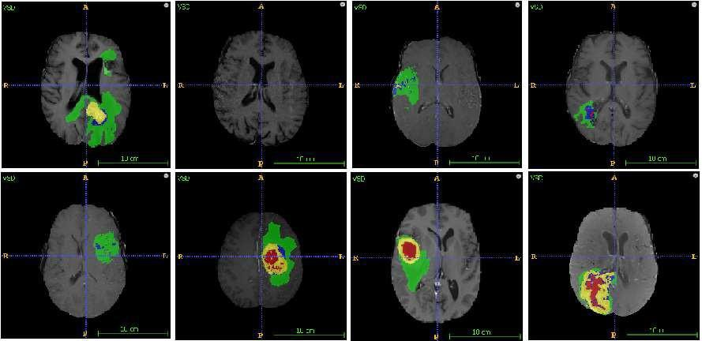

Fig.3.1 Location of tumors in eight different images.

This provides the architecture of the system that would be developed by our hands. It consists of six steps where the execution starts from taking an input image from the data set followed by the image pre-processing, image enhancement, Image segmentation using binary thresholding and the brain tumor classification using Convolutional Neural Network. Finally, the output is observed after all the above- mentioned steps are completed.

Each module is unique in its own way. Every step has its importance. This architecture also includes a testing and training data set. The data set used is has been downloaded from Kaggle which consists of nearly 2000 images that are used to test and train the system. The input image is pre-processed by using the noise filter like Median Filter and Bilateral Filter and the image is enhanced using the Sobel Filter. Then the obtained image using segmented using binary thresholding and morphological operations are performed on it. Finally, the image classification is done using Convolutional Neural Network to predict whether the tumor is present or not.

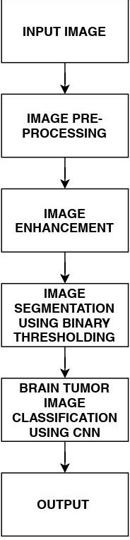

Fig 4.1 Module Division

**MODULE 1: IMAGE PREPROCESSING AND IMAGE ENHANCEMENT**

**4.1.1 IMAGE PREPROCESSING:**

The Brain MRI image dataset has been downloaded from the Kaggle. The MRI dataset consists of around 1900 MRI images, including normal, benign, and malignant. These MRI images are taken as input to the primary step. The pre-processing is an essential and initial step in improving the quality of the brain MRI Image. The critical steps in pre-processing are the reduction of impulsive noises and image resizing. In the initial phase, we convert the brain MRI image into its corresponding gray-scale image. The removal of unwanted noise is done using the adaptive bilateral filtering technique to remove the distorted noises that are present in the brain picture. This improves the diagnosis and also increase the classification accuracy rate.

In image processing, image acquisition is done by retrieving an image from dataset for processing. It is the first step in the workflow sequence because, without an image no processing is possible. The image that is acquired is completely unprocessed. Here we process the image using the file path from the local device.

**4.1.1.2 CONVERT THE IMAGE FROM ONE COLOR SPACE TO ANOTHER:**

There are more than 150 color-space conversion methods available in OpenCV. For color conversion, we use the function cv2.cvtColor(input_image, flag) where flag determines the type of conversion. In our work, we convert the input image into the gray-scale image.

**4.1.1.3 FILTERS:**

In image processing, filters are mainly used to suppress the high frequencies in the image.

**Median filter:** It is a non-linear filtering technique used to remove noise from the images. It is performed by sorting all the pixel values from the window into numerical order and then replacing the pixel being considered with the median pixel value. This filter removes the speckle noise and salt and pepper noise through ‘ON’ and

‘OFF’ of pixels by white and dark spots.

**Bilateral filter:** It is also a non-linear, noise-reducing smoothing filter for images. It replaces the intensity of each pixel with a weighted average of intensity values from nearby pixels. This weight is based on the Gaussian distribution. Bilateral filtering smooth images while conserving edges utilizing a nonlinear grouping of neighbouring image pixels. This filtering technique is simple, local, and concise. It syndicates a grey level grounded on their likeness and the symmetrical nearness and chooses near vales to farther values in both range and domain.

Image enhancement is a technique used to improve the image quality and perceptibility by using computer-aided software. This technique includes both objective and subjective enhancements. This technique includes points and local operations. The local operations depend on the district input pixel values. Image enhancement has two types: spatial and transform domain techniques. The spatial techniques work directly on the pixel level, while the transform technique works on Fourier and later on the spatial technique.

Edge detection is a segmentation technique that uses border recognition of strictly linked objects or regions. This technique identifies the discontinuity of the objects. This technique is used mainly in image study and to recognize the parts of the image where a huge variation in intensity arises.

**4.1.2.1 SOBEL FILTER:**

The Sobel filter is used for edge detection. It works by calculating the gradient of image intensity at each pixel within the image. It is widely used in image analysis to help locate edges in images. Sobel operator is used for segmentation purpose. This technique can be dependent on the central difference which tends toward the central pixels on average. This technique can be expressed as 3 × 3 matric to the first derivative of the Gaussian kernel. It combines smoothing and differentiation. For Sobel edge detection the gradient of the image is calculated for each pixel position in the image.

1. We calculate two derivatives:

a. **Horizontal changes**: This is computed by convolving I with a kernel Gx with odd size. For example, for a kernel size of 3, Gx would be computed as:

**Gx =** [[-1 0 +1] [-2 0 +2]

[-1 0 +1]]

b. **Vertical changes**: This is computed by convolving I with a kernel Gy with odd size. For example, for a kernel size of 3, Gy would be computed as:

**Gy** = [[-1 -2 -1] [ 0 0 0] [+1 +2 +1]]

2. At each point of the image we calculate an approximation of the *gradient* in that point by combining both results above:

G=(G2x+G2y)1/2

3. Although sometimes the following simpler equation is used: G=|Gx|+|Gy|

After the completion of the pre-processing, the image will be free from the noises, but we still need to enhance the image since the obtained image is smoothened, edges may not be preserved, and the image will be dull. To overcome all these, we used edge detection called Sobel filtering technique. The whole thing is done by calculating the gradient of image intensities at each pixel within the image. It is widely used in image analysis to help locate edges in images. It will also enhance the darker areas of the image, slightly increase contrast and as sharp as possible.

**MODULE 2: IMAGE SEGMENTATION USING BINARY THRESHOLD**

Image segmentation is a technique of segregating the image into many parts. The basic aim of this segregation is to make the images easy to analyze and interpret with preserving the quality. This technique is also used to trace the objects’ borders within the images. This technique labels the pixels according to their intensity and characteristics. Those parts represent the entire original image and acquire its characteristics such as intensity and similarity. The image segmentation technique is used to create contours of the body for clinical purposes. Segmentation is used in

machine perception, malignant disease analysis, tissue volumes, anatomical and functional analyses, virtual reality visualization, and anomaly analysis, and object definition and detection.

Segmentation methods has ability to detect or identify the abnormal portion from the image which is useful for analyzing the size, volume, location, texture and shape of the extracted image. MR image segmentation with the aid of preserving the threshold information, which is convenient to identify the broken regions extra precisely. It was a trendy surmise that the objects that are placed in close propinquity might be sharing similar houses and characteristics.

**4.2.1 THRESHOLDING:**

Thresholding is the simplest method of image segmentation. It is a non-linear operation that converts a grey-scale image into a binary image where the two levels are assigned to pixels that are below or above the specified threshold value. In Open CV, we use **cv2.threshold()** function:

cv2.threshold(src, thresh, maxval, type[dst])

This function applies fixed-level thresholding to a single-channel array. The function is typically used to get a bi-level (binary) image out of a grayscale image for removing a noise, that is, filtering out pixels with too small or too large values. “maxval” is the set threshold value which compares with input values, when the input is greater than the set threshold value it gives output is set maxval value and it is shown with white color in gray images. when the input pixel intensity values are less than the set threshold, its output is black color. There are several types of thresholding supported by the function.

The function returns the computed threshold value and thresholder image.

1. **src** - input array (single-channel, 8-bit or 32-bit floating point). This is the source image, which should be a grayscale image.

2. **thresh** - threshold value, and it is used to classify the pixel values.

3. **maxval** - maximum value to use with the THRESH_BINARY and THRESH_BINARY_INV thresholding types. It represents the value to be given if pixel value is more than (sometimes less than) the threshold value.

4. **type** - thresholding type

• cv2.THRESH_BINARY

• cv2.THRESH_BINARY_INVY

**4.2.2 MORPHOLOGICAL OPERATIONS:**

Morphological operations apply a structuring element to an input image, creating an output image of the same size. In a morphological operation, the value of each pixel in the output image is based on a comparison of the corresponding pixel in the input image with its neighbors.

The Morphological techniques are also used with segmentation techniques. The morphological action is normally performed on binary images. It processes the operations based on shape and it has a wide set of the image processing operation. Erosion and Dilation are two methods of morphological operations which used in this proposed work. We perform both Erosion and dilation operations used together.

Two main steps of the erosion and dilation morphological operation are opening and closing. The first step is the opening of the MRI binary image. The main work of opening operation is open up a gap which is present in between object and connect that to a small collection of pixels. After setting of the bridge, the erosion again restored with their actual size using dilation. If the binary image has been opened then the subsequent opened same structured elements have not affected on that image. After completing the opening operations next step is the closing operation. Based on the closing operation while keeping the original region sizes, the erosion and dilation can handle different hole in the image region. Dilation and Erosion are the basic morphological operations. Dilation adds pixels to the boundaries of objects in an image, while erosion removes pixels on object boundaries.

Watershed Method: considers the gradient magnitude of an image as a topographic surface where high gradient denotes peaks, while low gradient denotes valleys. Start by filling every isolated valley with different coloured water. As the water rises, water from different valleys will start to merge. To avoid that, barriers are built in the locations where water merges. Continue the work of filling water and building barriers until all the peaks are under water. Then the created barriers give the segmentation result.

**MODULE 3: BRAIN TUMOR IMAGE CLASSIFICATION USING CONVOLUTIONAL NEURAL NETWORK**

Classification is the best approaches for identification of images like any kind of medical imaging. All classification algorithms are based on the prediction of image, where one or more features and that each of these features belongs to one of several classes.

An automatic and reliable classification method Convolutional Neural Network (CNN) will be used since it is robust in structure which helps in identifying every minute details. A Convolutional Neural Network (ConvNet/CNN) is a Deep Learning algorithm which can take in an input image, assign importance to various aspects/objects in the image and be able to differentiate one from the other. The pre- processing required in a ConvNet is much lower as compared to other classification algorithms. While in primitive methods filters are hand-engineered, with enough training, ConvNet have the ability to learn these filters/characteristics.

A ConvNet is able to successfully capture the spatial and temporal dependencies in an image through the application of relevant filters. The architecture performs a better fitting to the image dataset due to the reduction in the number of parameters involved and reusability of weights. In other words, the network can be trained to understand the sophistication of the image better. The role of the ConvNet is to reduce the images into a form which is easier to process, without losing features which are critical for getting a good prediction.

For this step we need to import Keras and other packages that we’re going to use in

building the CNN. Import the following packages:

• *Sequential* is used to initialize the neural network.

• *Convolution2D* is used to make the convolutional network that deals with the images.

• *MaxPooling2D* layer is used to add the pooling layers.

• *Flatten* is the function that converts the pooled feature map to a single column that is passed to the fully connected layer.

• *Dense* adds the fully connected layer to the neural network.

**4.3.1 SEQUENTIAL:**

• To initialize the neural network, we create an object of the Sequential class.

• ***classifier = Sequential ()***

**4.3.2 CONVOLUTION:**

• To add the convolution layer, we call the *add* function with the classifier object and pass in *Convolution2D* with parameters. The first argument *feature_detectors* which is the number of feature detectors that we want to create. The second and third parameters are dimensions of the feature detector matrix.

• We used 256 feature detectors for CNNs. The next parameter is *input shape* which is the shape of the input image. The images will be converted into this shape during pre-processing. If the image is black and white it will be converted into a 2D array and if the image is coloured it will be converted into a

3D array.

• In this case, we’ll assume that we are working with coloured images. *Input_shape* is passed in a tuple with the number of channels, which is 3 for a coloured image, and the dimensions of the 2D array in each channel. If you are not using a GPU it’s advisable to use lower dimensions to reduce the computation time. The final parameter is the activation function. Classifying images is a nonlinear problem. So, we use the rectifier function to ensure that we don’t have negative pixel values during computation. That’s how we achieve non-linearity.

• ***classifier.add (Convolution2D (256, 3, 3, input_shape = (256, 256, 3),***

***activation=’relu’))***

**4.3.3 POOLING:**

• The Pooling layer is responsible for reducing the spatial size of the convolved feature. This is to decrease the computational power required to process the data through dimensionality reduction. Furthermore, it is useful for extracting dominant features which are rotational and positional invariant, thus maintaining the process of effectively training of the model.

• There are two types of Pooling: Max Pooling and Average Pooling.

Max Pooling returns the maximum value from the portion of the image covered by the Kernel. On the other hand, Average Pooling returns the average of all the values from the portion of the image covered by the Kernel. Generally, we use max pooling.

• In this step we reduce the size of the feature map. Generally, we create a pool size of 2x2 for max pooling. This enables us to reduce the size of the feature map while not losing important image information.

• ***classifier.add (MaxPooling2D (pool_size= (2,2)))***

**4.3.4 FLATTENING:**

• In this step, all the pooled feature maps are taken and put into a single vector for inputting it to the next layer.

• The *Flatten* function flattens all the feature maps into a single long column.

• ***classifier.add (Flatten ())***

**4.3.5 FULLY CONNECTION:**

• The next step is to use the vector we obtained above as the input for the neural network by using the *Dense* function in Keras. The first parameter is *output* which is the number of nodes in the hidden layer. You can determine the most appropriate number through experimentation. The higher the number of dimensions the more computing resources you will need to fit the model. A common practice is to pick the number of nodes in powers of two.

• ***classifier.add (Dense (output = 64))***

• The next layer we have to add is the output layer. In this case, we’ll use the *sigmoid* activation function since we expect a binary outcome. If we expected more than two outcomes, we would use the *SoftMax* function.

• The *output* here is 1 since we just expect the predicted probabilities of the classes.

• *c****lassifier.add (Dense (output=1, activation=’sigmoid’))***

**5. EXPERIMENTAL ANALYSIS AND RESULTS**

**5.1 SYSTEM CONFIGURATION**

**5.1.1 SOFTWARE REQUIREMENTS**

• Windows: Python 3.6.2 or above, PIP and NumPy 1.13.1

**Python:**

Python is an interpreted, high-level, general purpose programming language created by Guido Van Rossum and first released in 1991, Python's design philosophy emphasizes code Readability with its notable use of significant Whitespace. Its language constructs and object-oriented approach aim to help programmers write clear, logical code for small and large-scale projects. Python is dynamically typed and garbage collected. It supports multiple programming paradigms, including procedural, object-oriented, and functional programming.

**PIP:**

It is the package management system used to install and manage software packages written in Python.

**NumPy:**

NumPy is a general-purpose array-processing package. It provides a high- performance multidimensional array object, and tools for working with these arrays. It is the fundamental package for scientific computing with Python. It contains various features including these important ones:

• A powerful N-dimensional array object

• Sophisticated (broadcasting) functions

• Tools for integrating C/C++ and Fortran code

• Useful linear algebra, Fourier transform, and random number capabilities

**Pandas:**

*Pandas* is the most popular python library that is used for data analysis. It provides highly optimized performance with back-end source code is purely written in *C* or *Python*. We can analyze data in pandas with

1. Series

2. Data frames

**Anaconda:**

Anaconda is a free and open-source distribution of the Python and R programming languages for scientific computing that aims to simplify package management and deployment. Package versions are managed by the package management system conda. The Anaconda distribution includes data-science packages suitable for Windows, Linux, and macOS. Anaconda distribution comes with 1,500 packages selected from PyPI as well as the conda package and virtual environment manager. It also includes a GUI, Anaconda Navigator, as a graphical alternative to the command-line interface (CLI).

**Jupyter Notebook:**

Anaconda distribution comes with 1,500 packages selected from PyPI as well as the conda package and virtual environment manager. It also includes a GUI, Anaconda Navigator, as a graphical alternative to the command line interface (CLI). A Jupyter Notebook document is a JSON document, following a versioned schema, and containing an ordered list of input/output cells which can contain code, text mathematics, plots and rich media, usually ending with the “. ipynb" extension.

**Tensor Flow:**

Tensor flow is a free and open-source software library for dataflow and differentiable programming across a range of tasks. It is a symbolic math library, and is also used for machine learning applications such as neural networks. It is used for both research and production at Google.

**Keras:**

Keras is an open-source neural-network library written in Python. It is capable of running on top of TensorFlow, Microsoft Cognitive Toolkit, R, Theano, or Plaid ML. Designed to enable fast experimentation with deep neural networks, it focuses on being user-friendly, modular, and extensible. Keras contains numerous implementations of commonly used neural-network building blocks such as layers, objectives, activation functions, optimizers, and a host of tools to make working with image and text data easier to simplify the coding necessary for writing deep neural network code.

**OpenCV:**

OpenCV (Open source computer vision) is a library of programming functions mainly aimed at real-time computer vision. Originally developed by Intel, it was later supported by willow garage then Itseez (which was later acquired by Intel). The library is cross platform and free for use under the open source BSD license. OpenCV supports some models from deep learning frameworks like TensorFlow, Torch, PyTorch (after converting to an ONNX model) and Caffe according to a defined list of supported layers. It promotes Open Vision Capsules. which is a portable format, compatible with all other formats.

**5.1.2 HARDWARE CONFIGURATION**

• Processor: Intel core i5 or above.

• 64-bit, quad-core, 2.5 GHz minimum per core

• Ram: 4 GB or more

• Hard disk: 10 GB of available space or more.

• Display: Dual XGA (1024 x 768) or higher resolution monitors

• Operating system: Windows

**5.2 SAMPLE CODE:**

**#MRI.py**

from tkinter import messagebox

from tkinter import *

from tkinter import simpledialog

import tkinter

from tkinter import filedialog

import matplotlib.pyplot as plt

import numpy as np

from tkinter.filedialog import askopenfilename

import os

import cv2

from sklearn.model_selection import train_test_split

from sklearn.metrics import accuracy_score

import imutils

from keras.utils.np_utils import to_categorical

from keras.layers import MaxPooling2D

from keras.layers import Dense, Dropout, Activation, Flatten

from keras.layers import Convolution2D

from keras.models import Sequential

from keras.models import model_from_json

import pickle

from sklearn import metrics

import ftplib

from tkinter import ttk

main = tkinter.Tk()

main.title("A Generic Model to Analyze and Predict Brain Tumor from MRI And CT Medical Images Using Deep Learning") #designing main screen

main.geometry("1300x1200")

global filename

global accuracy

X = []

Y = []

global classifier

disease = ['No Tumor Detected','Tumor Detected']

def upload(): #function to upload tweeter profile

global filename

filename = filedialog.askdirectory(initialdir=".")

text.delete('1.0', END)

text.insert(END,filename+" loaded\n");

def generateModel():

global X

global Y

X.clear()

Y.clear()

if os.path.exists('Model/myimg_data.txt.npy'):

X = np.load('Model/myimg_data.txt.npy')

Y = np.load('Model/myimg_label.txt.npy')

else:

for root, dirs, directory in os.walk(filename+"/no"):

for i in range(len(directory)):

name = directory[i]

img = cv2.imread(filename+"/no/"+name,0)

ret2,th2 = cv.threshold(img,0,255,cv.THRESH_BINARY+cv.THRESH_OTSU)

img = cv2.resize(img, (128,128))

im2arr = np.array(img)

im2arr = im2arr.reshape(128,128,1)

X.append(im2arr)

Y.append(0)

print(filename+"/no/"+name)

for root, dirs, directory in os.walk(filename+"/yes"):

for i in range(len(directory)):

name = directory[i]

img = cv2.imread(filename+"/yes/"+name,0)

ret2,th2 = cv.threshold(img,0,255,cv.THRESH_BINARY+cv.THRESH_OTSU)

img = cv2.resize(img, (128,128))

im2arr = np.array(img)

im2arr = im2arr.reshape(128,128,1)

X.append(im2arr)

Y.append(1)

print(filename+"/yes/"+name)

X = np.asarray(X)

Y = np.asarray(Y)

np.save("Model/myimg_data.txt",X)

np.save("Model/myimg_label.txt",Y)

print(X.shape)

print(Y.shape)

print(Y)

cv2.imshow('ss',X[20])

cv2.waitKey(0)

text.insert(END,"Total number of images found in dataset : "+str(len(X))+"\n")

text.insert(END,"Total number of classes : "+str(len(set(Y)))+"\n\n")

def CNN():

global accuracy

global classifier

YY = to_categorical(Y)

indices = np.arange(X.shape[0])

np.random.shuffle(indices)

x_train = X[indices]

y_train = YY[indices]

if os.path.exists('Model/model.json'):

with open('Model/model.json', "r") as json_file:

loaded_model_json = json_file.read()

classifier = model_from_json(loaded_model_json)

classifier.load_weights("Model/model_weights.h5")

classifier.make_predict_function()

print(classifier.summary())

f = open('Model/history.pckl', 'rb')

data = pickle.load(f)

f.close()

acc = data['accuracy']

accuracy = acc[9] * 100

text.insert(END,'\n\nCNN Model Generated. See black console to view layers of CNN\n\n')

text.insert(END,"CNN Prediction Accuracy on Test Images : "+str(accuracy)+"\n")

else:

X_trains, X_tests, y_trains, y_tests = train_test_split(x_train, y_train, test_size = 0.2, random_state = 0)

classifier = Sequential() #alexnet transfer learning code here

classifier.add(Convolution2D(32, 3, 3, input_shape = (128, 128, 1), activation = 'relu'))

classifier.add(MaxPooling2D(pool_size = (2, 2)))

classifier.add(Convolution2D(32, 3, 3, activation = 'relu'))

classifier.add(MaxPooling2D(pool_size = (2, 2)))

classifier.add(Flatten())

classifier.add(Dense(output_dim = 128, activation = 'relu'))

classifier.add(Dense(output_dim = 2, activation = 'softmax'))

print(classifier.summary())

classifier.compile(optimizer = 'adam', loss = 'categorical_crossentropy', metrics = ['accuracy'])

hist = classifier.fit(x_train, y_train, batch_size=16, epochs=10,validation_split=0.2, shuffle=True, verbose=2)

classifier.save_weights('Model/model_weights.h5')

model_json = classifier.to_json()

with open("Model/model.json", "w") as json_file:

json_file.write(model_json)

f = open('Model/history.pckl', 'wb')

pickle.dump(hist.history, f)

f.close()

f = open('Model/history.pckl', 'rb')

data = pickle.load(f)

f.close()

acc = data['accuracy']

accuracy = acc[9] * 100

text.insert(END,'\n\nCNN Model Generated. See black console to view layers of CNN\n\n')

text.insert(END,"CNN Prediction Accuracy on Test Images : "+str(accuracy)+"\n")

def predict():

ftp = ftplib.FTP_TLS("ftp.drivehq.com")

ftp.login("vitdrivehq2018", "vit2216487")

ftp.prot_p()

name = imagelist.get()

with open('drivehq.jpg', 'wb' ) as file :

ftp.retrbinary('RETR %s' % name, file.write)

file.close()

img = cv2.imread('drivehq.jpg',0)

img = cv2.resize(img, (128,128))

im2arr = np.array(img)

im2arr = im2arr.reshape(1,128,128,1)

XX = np.asarray(im2arr)

predicts = classifier.predict(XX)

print(predicts)

cls = np.argmax(predicts)

print(cls)

img = cv2.imread('drivehq.jpg')

img = cv2.resize(img, (800,500))

cv2.putText(img, 'Disease Identified as : '+disease[cls], (10, 25), cv2.FONT_HERSHEY_SIMPLEX,0.7, (0, 255, 255), 2)

cv2.imshow('Disease Identified as : '+disease[cls], img)

cv2.waitKey(0)

def getImages():

ftp = ftplib.FTP_TLS("ftp.drivehq.com")

ftp.login("vitdrivehq2018", "vit2216487")

ftp.prot_p()

filenames = ftp.nlst()

value.clear()

for filename in filenames:

value.append(filename)

font = ('times', 16, 'bold')

title = Label(main, text='A Generic Model To Analyse And Predict Brain Tumor From MRI And CT Medical Images Using Deep Learning')

title.config(bg='darkviolet', fg='gold')

title.config(font=font)

title.config(height=3, width=120)

title.place(x=0,y=5)

font1 = ('times', 12, 'bold')

text=Text(main,height=20,width=150)

scroll=Scrollbar(text)

text.configure(yscrollcommand=scroll.set)

text.place(x=50,y=120)

text.config(font=font1)

font1 = ('times', 12, 'bold')

uploadButton = Button(main, text="Upload MRI Images Dataset", command=upload)

uploadButton.place(x=50,y=550)

uploadButton.config(font=font1)

modelButton = Button(main, text="Generate Images Train & Test Model (OSTU Features)", command=generateModel)

modelButton.place(x=290,y=550)

modelButton.config(font=font1)

cnnButton = Button(main, text="Generate Deep Learning CNN Model", command=CNN)

cnnButton.place(x=710,y=550)

cnnButton.config(font=font1)

imageButton = Button(main, text="Get DriveHQ Images", command=getImages)

imageButton.place(x=50,y=600)

imageButton.config(font=font1)

value = ["DriveHQ Images"]

imagelist = ttk.Combobox(main,values=value,postcommand=lambda: imagelist.configure(values=value))

imagelist.place(x=240,y=600)

imagelist.current(0)

imagelist.config(font=font1)

predictButton = Button(main, text="Predict Tumor", command=predict)

predictButton.place(x=440,y=600)

predictButton.config(font=font1)

main.config(bg='turquoise')

main.mainloop(

**5.3 EXPERIMENTAL RESULTS:**

In this project we are using brain tumor MRI images to build deep learning auto stack CNN model. To implement this project we are using following modules.

1. Upload MRI image: using this module we are uploading MRI train images and then application read all images and convert them grey format.
2. Ostu Thresholding: Using this module we will apply OSTU thresholding technique on each image to extract features.
3. Generate Train & Test Model: Using this module we will build array of pixels with all images features and then split dataset into train and test model to calculate accuracy using test images by applying train model on it.
4. Generate Deep Learning CNN Model: Using this module will input train and test data to auto stack CNN model to build training classifier.
5. Get DriveHQ Images: Using this module we will read test image from DriveHQ website and then application will apply CNN classifier model on that test image to predict whether image contains tumour disease or not.

Actually student wants to read all images from DriveHQ but it will take lots of time to read from DriveHQ using internet as train data contains nearly 260 images. So I put some test image on DriveHQ while testing CNN model you can read images from DriveHQ and predict tumour.

Below screen showing some images saved at DriveHQ

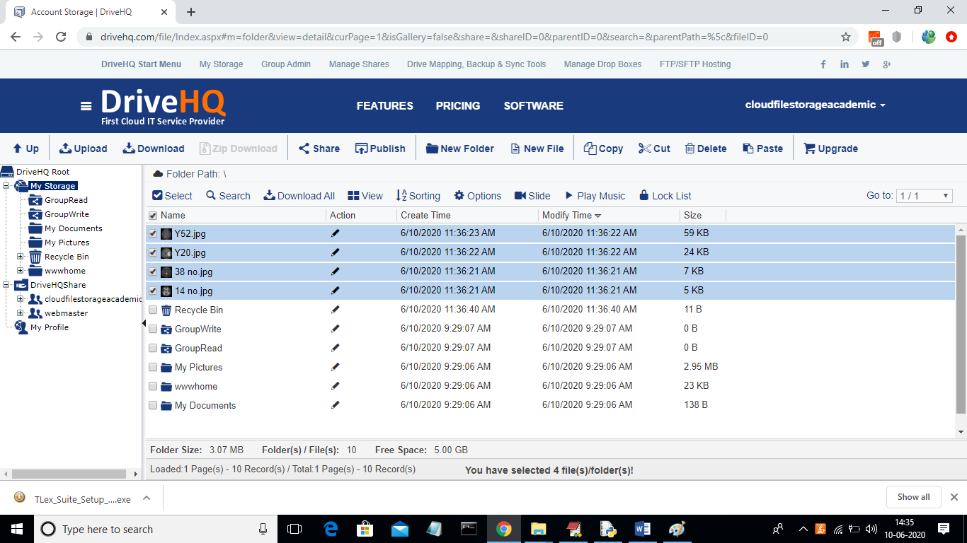

In above DriveHQ screen we can see some brain MRI images are stored and application will download from here. If you want you can also upload few images in above screen and then application will read new images also.

To run project double click on ‘run.bat’ file to get below screen

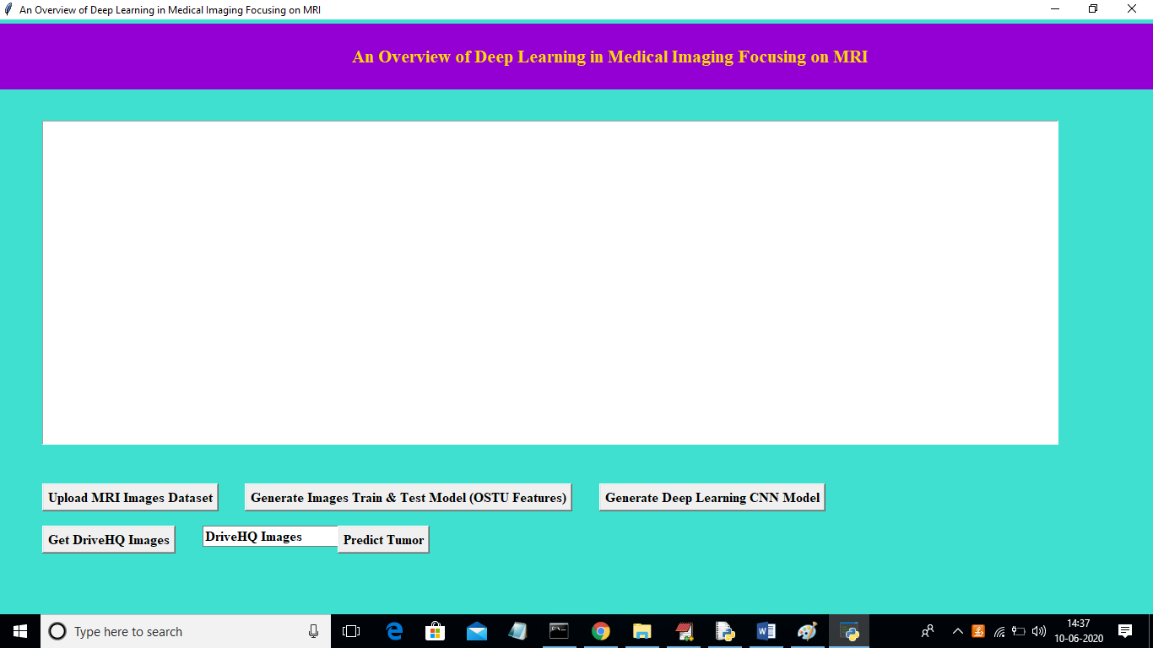

In above screen click on ‘Upload MRI Images Dataset’ button and upload images directory

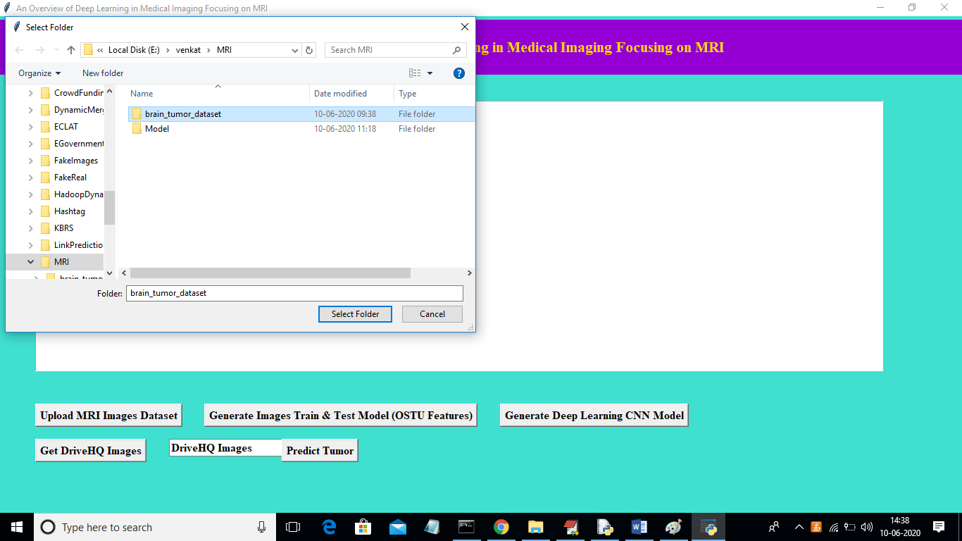

In above screen I am uploading complete folder called ‘brain_tumor_dataset’ which contains images with and without tumour. Now click on ‘Select Folder’ button to get below screen.

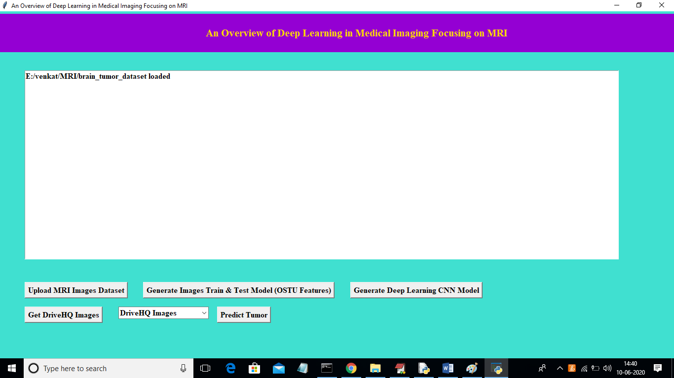

In above screen click on ‘Generate Images Train & Test Model (OSTU Features)’ button to read images and then extract features using OSTU and then build train and test model

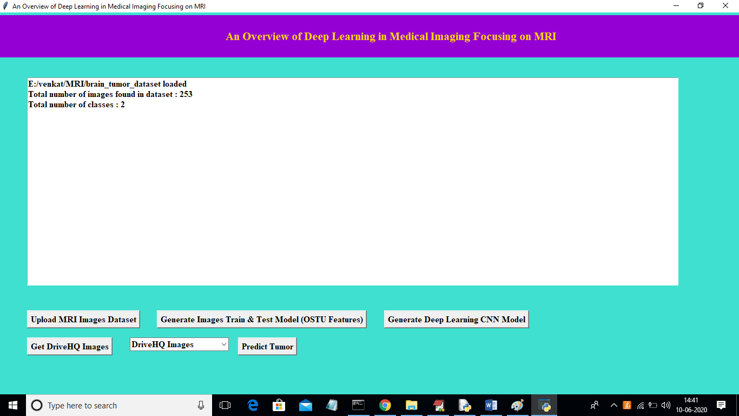

In above screen we can see dataset contains total 253 images and those images belongs to 2 classes called ‘yes’ or ‘no’. yes means tumour is there and no means no tumour. Now click on ‘Generate Deep Learning CNN Model’ button to generate CNN classifier.

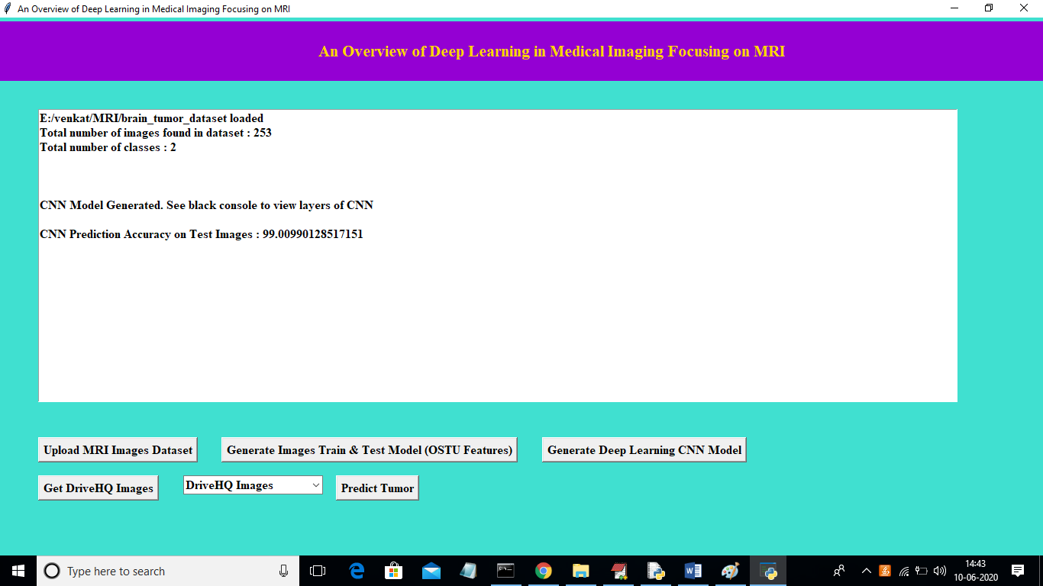

In above screen we got CNN test images prediction accuracy as ’99.009%’ and we can see below black console to see CNN layer details

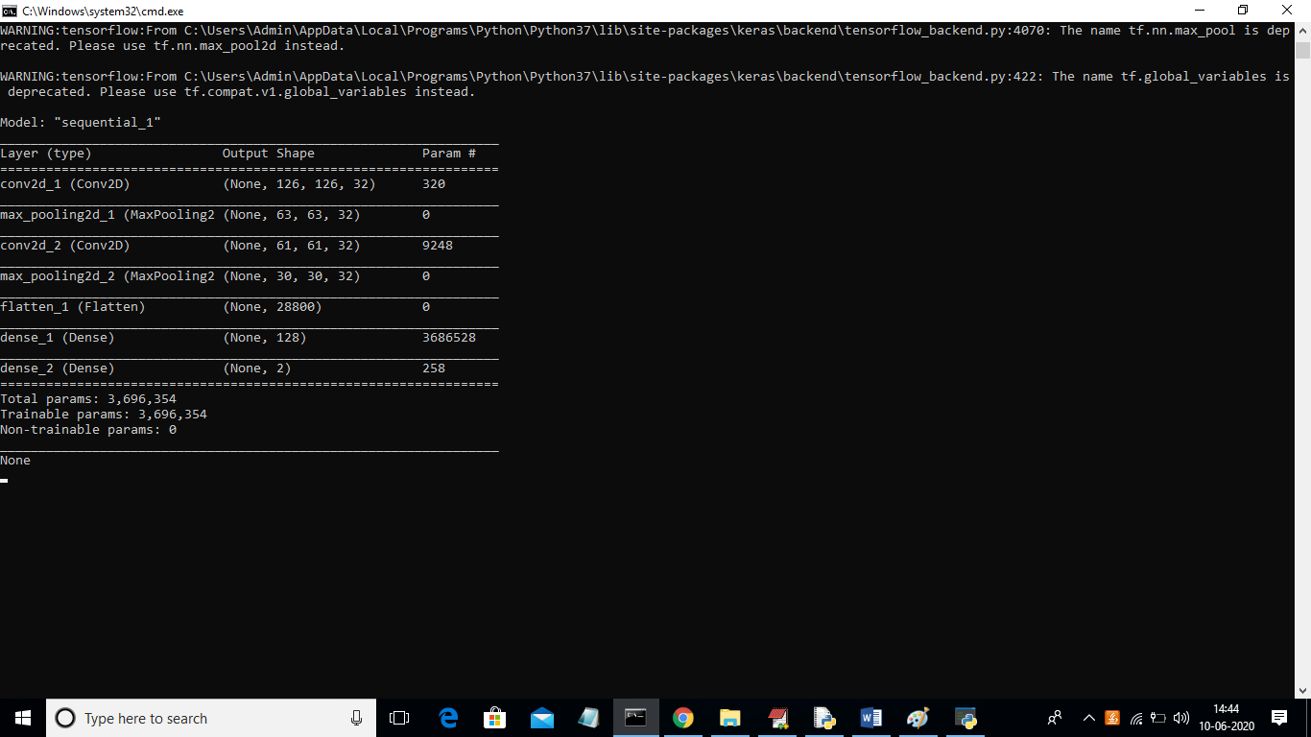

In above screen auto stack CNN using 4 layers to build filter CNN classifier with 4 different images size. First layer built using 126 X 126 image size and second with 63 and goes on. With this layer we got 99% accuracy. In below screen we have DriveHQ drop down box with no image names

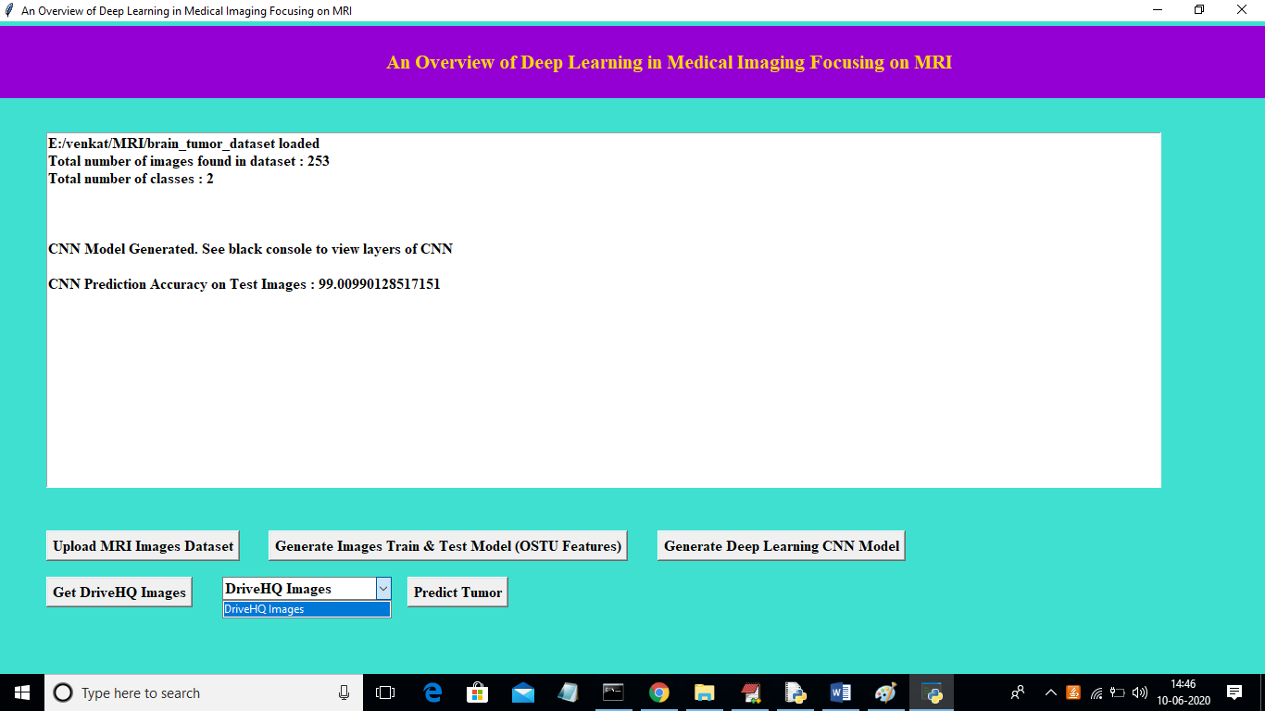

In above screen in DriveHQ Images drop down box there are no images and to read available images from DriveHQ click on ‘Get DriveHQ Images’ button. After clicking that button we can see all images names from DriveHQ will display in drop down box and then we can select any image and click on ‘Predict Tumour’ button to predict disease.

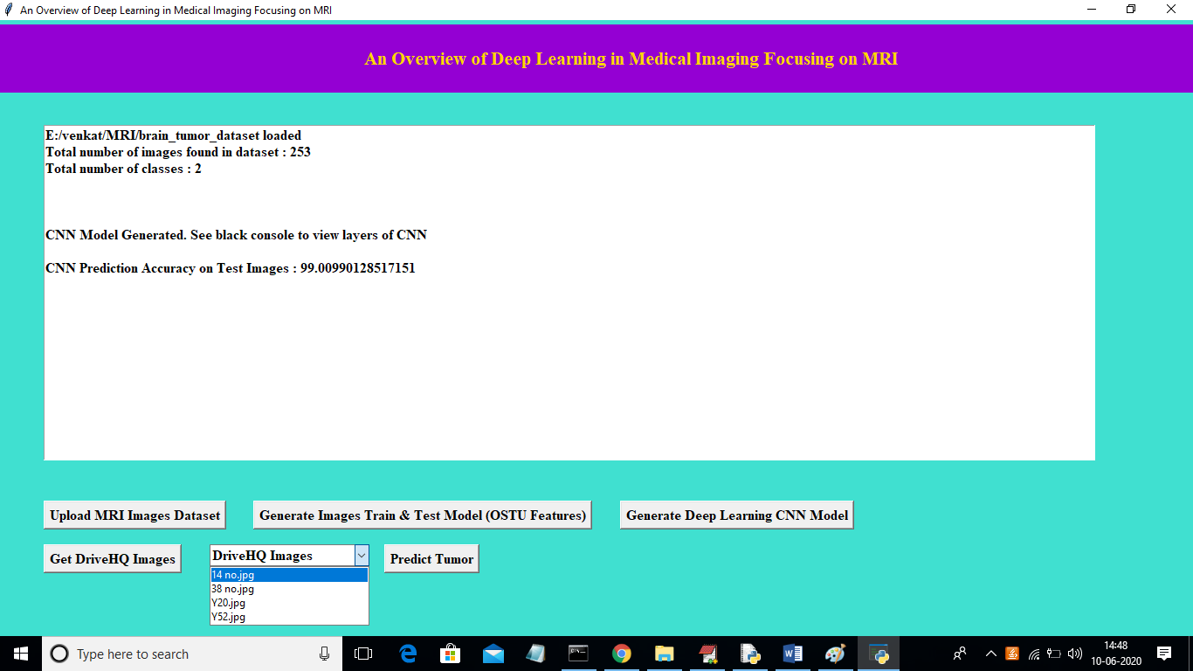

In above screen we can see all images list displaying in drop down box from DriveHQ and then select any image and click on ‘Predict Tumour’ button

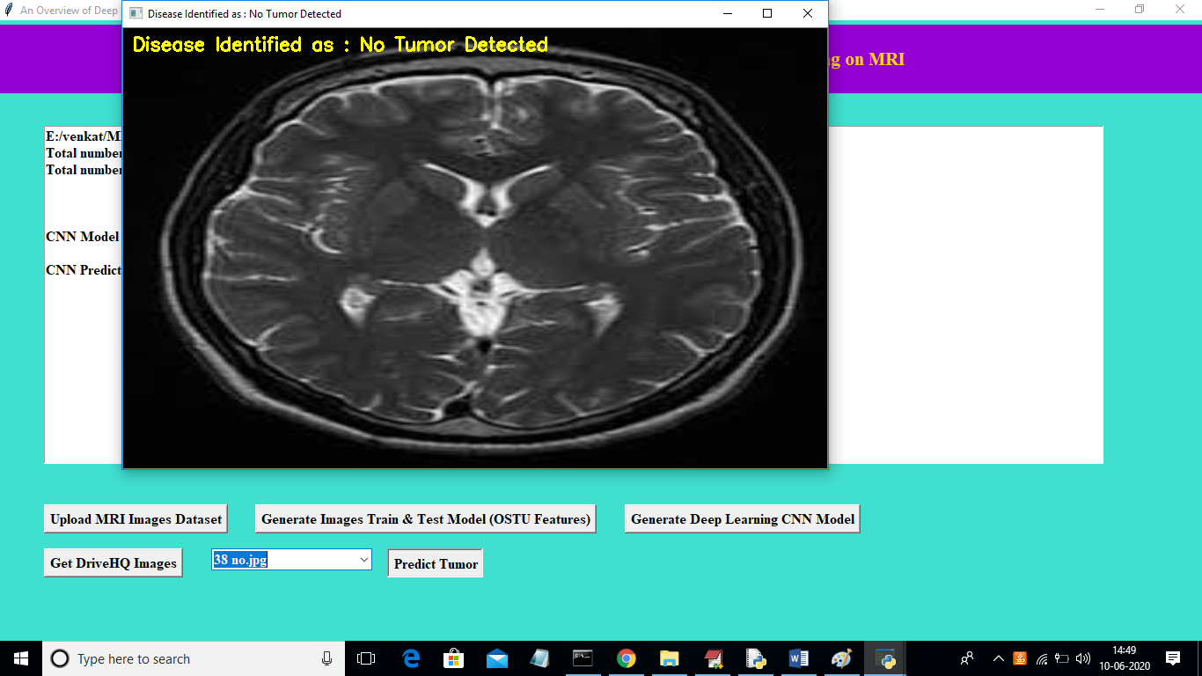

In above screen from drop down box I selected images as ’38 no.jpg’ and then application download that image from DriveHQ and then apply CNN classifier to predict tumour. In above image we can see predicted result as ‘No Tumor Detected’. Now I will upload another image and test

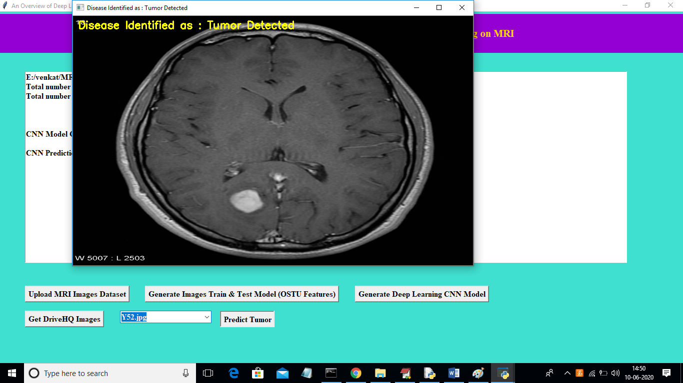

In above screen from drop down box I selected image as ‘Y52.jpg’ and its predicted disease as ‘Tumor Detected’. Similarly you can upload any MRI images on DriveHQ and perform prediction

**5.4 PERFORMANCE MEASURES:**

The proposed algorithm has been assessed through various performance evaluation metrics that include True Positive, True Negative the former one that designates how many times does the proposed algorithm is able to correctly recognize the damaged region as damaged region and the later one designates how many times does the proposed algorithm correctly identified non-damaged region as non-damaged region. And the False Positive (FN) and False Negative (FN) the former one designates how many times does the proposed algorithm fails to recognize the damaged region correctly, and the later represents how many times does the proposed algorithm fails to identify the non-tumors region as non-tumors regions. Basing on values of TP, TN, FP, and FN, the values of Accuracy, Specificity and sensitivity are calculated of the

proposed algorithm.

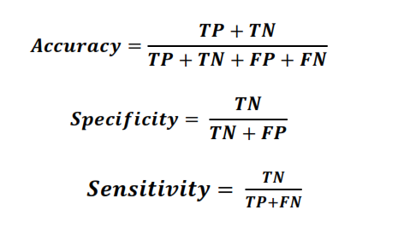

**5.5 PERFORMANCE EVALUTION:**

On experimentation, it was observed that the proposed methodology seems to be outperformed when compared to all different set of images. Among all the images, the proposed Convolutional Neural Network (CNN) based approach seems too much better in terms of quality of the output in 128 *128 images when compared to its other sized images which are represented in table and charts.

**TABLE 1** Represents the true positive, true negative, false positive and false negative values of the proposed approach for different set of images.

|  |  |  |  |  |  |  |  |  |  |  |  |  |
| --- | --- | --- | --- | --- | --- | --- | --- | --- | --- | --- | --- | --- |
|  | |  |  |  |  |  |  |  |  |  |  |  |
|  | |  |  |  |  |  |  |  |  |  |  |  |
|  | |  |  |  |  |  |  |  |  |  |  |  |
|  |  | | |  |  |  |  |  |  |  |  |  |
|  | | |  |  |  |  |  |  |  |  |  |  |
|  | | |  |  |  |  |  |  |  |  |  |
|  | |  | |  |  |  |  |  |  |  |  |  |
|  |  | | |  |  |  |  |  |  |  |  |  |
|  | | | | | | | | | | | |  |
|  | | | | | | | | | | | |  |
|  | | | | | | | | | | | |  |
|  |  | | |  |  |  |  |  |  |  | | |
|  | | | | | | | | | | |  | |
|  | | | | | | | | | | |
|  | | | | | | | | | | | |  |
|  |  | | |  |  |  |  |  |  |  | |

|  |  |  |  |  |
| --- | --- | --- | --- | --- |
| **Different set of**  **Images** | **True**  **Positive (%)** | **True**  **Negative (%)** | **False**  **Positive**  **(%)** | **False**  **Negative**  **(%)** |
| **128 * 128 Images** | **83.7** | **84.5** | **16.3** | **15.5** |
| **256 * 256 Images** | **82.4** | **84.1** | **17.6** | **15.9** |
| **512 * 512 Images** | **82.1** | **83.7** | **17.9** | **16.3** |

Performance Analysis Chart

False Negative (%)

False Positive (%)

True Negative (%)

True Positive (%)

0 10 20 30 40 50 60 70 80 90

512 * 512 Images 256 * 256 Images 128 * 128 Images

**Fig. 5.9** Represents the performance analysis of CNN

It is observed from table 2 upon performing proposed segmentation technique for different set of images that have the ability to recognize the isolated region from the MR images that are used to analyze the shape and size of the denoised image. We have used Convolutional Neural Network (CNN) for segmentation, and the output of our proposed work is pleased with better accuracy, sensitivity, and computational time.

**TABLE 2** Represents the Accuracy, Sensitivity, and Specificity of the proposed approach for different set of images.

|  |  |  |  |
| --- | --- | --- | --- |
| **Different set of**  **Images** | **Accuracy (%)** | **Sensitivity (%)** | **Specificity (%)** |
| **128 * 128 Images** | **84.1** | **84.4** | **83.8** |
| **256 * 256 Images** | **83.3** | **83.4** | **82.7** |
| **512 * 512 Images** | **82.9** | **83.3** | **82.4** |

85

84.5

84

83.5

83

82.5

82

81.5

81

Accuracy, Sensitivity and Specificity of the Proposed

approach.

Accuracy (%) Sensitivity (%) Specificity (%)

128 * 128 Images 256 * 256 Images 512 * 512 Images

**Fig. 5.10** Represents the performance of proposed CNN

**6. CONCLUSION AND FUTURE SCOPE**

**6.1 CONCLUSION:**

We proposed a computerized method for the segmentation and identification of a brain tumor using the Convolution Neural Network. The input MR images are read from the local device using the file path and converted into grayscale images. These images are pre-processed using an adaptive bilateral filtering technique for the elimination of noises that are present inside the original image. The binary thresholding is applied to the denoised image, and Convolution Neural Network segmentation is applied, which helps in figuring out the tumor region in the MR images. The proposed model had obtained an accuracy of 84% and yields promising results without any errors and much less computational time.

**6.2 FUTURE SCOPE:**

It is observed on extermination that the proposed approach needs a vast training set for better accurate results; in the field of medical image processing, the gathering of medical data is a tedious job, and, in few cases, the datasets might not be available. In all such cases, the proposed algorithm must be robust enough for accurate recognition of tumor regions from MR Images. The proposed approach can be further improvised through in cooperating weakly trained algorithms that can identify the abnormalities with a minimum training data and also self-learning algorithms would aid in enhancing the accuracy of the algorithm and reduce the computational time.

**REFERENCES**

[1] A. Sivaramakrishnan And Dr.M.Karnan “A Novel Based Approach For Extraction Of Brain Tumor In MRI Images Using Soft Computing Techniques,” International Journal Of Advanced Research In Computer And Communication Engineering, Vol. 2, Issue 4, April 2013.

[2] Asra Aslam, Ekram Khan, M.M. Sufyan Beg, Improved Edge Detection

Algorithm for Brain Tumor Segmentation, Procedia Computer Science, Volume

58,2015, Pp 430-437, ISSN 1877-0509.

[3] B.Sathya and R.Manavalan, Image Segmentation by Clustering Methods: Performance Analysis, International Journal of Computer Applications (0975 – 8887) Volume 29– No.11, September 2011.

[4] Devkota, B. & Alsadoon, Abeer & Prasad, P.W.C. & Singh, A.K. & Elchouemi, A.. (2018). Image Segmentation for Early Stage Brain Tumor Detection using Mathematical Morphological Reconstruction. Procedia Computer Science. 125. 115-

123. 10.1016/j.procs.2017.12.017.

[5] K. Sudharani, T. C. Sarma and K. Satya Rasad, "Intelligent Brain Tumor lesion classification and identification from MRI images using k-NN technique," 2015

International Conference on Control, Instrumentation, Communication and

Computational Technologies (ICCICCT), Kumaracoil, 2015, pp. 777-780. DOI:

10.1109/ICCICCT.2015.7475384

[6] Kaur, Jaskirat & Agrawal, Sunil & Renu, Vig. (2012). A Comparative Analysis of Thresholding and Edge Detection Segmentation Techniques. International Journal of Computer Applications.vol. 39.pp. 29-34. 10.5120/4898-7432.

[7] Li, Shutao, JT-Y. Kwok, IW-H. Tsang and Yaonan Wang. "Fusing images with different focuses using support vector machines." IEEE Transactions on neural networks 15, no. 6 (2004): 1555-1561.

[8] M. Kumar and K. K. Mehta, "A Texture based Tumor detection and automatic

Segmentation using Seeded Region Growing Method," International Journal of

Computer Technology and Applications, ISSN: 2229-6093, Vol. 2, Issue 4, PP. 855-

859 August 2011.

[9] Mahmoud, Dalia & Mohamed, Eltaher. (2012). Brain Tumor Detection Using

Artificial Neural Networks. Journal of Science and Technology. 13. 31-39.

[10] Marroquin J.L., Vemuri B.C., Botello S., Calderon F. (2002) An Accurate and Efficient Bayesian Method for Automatic Segmentation of Brain MRI. In: Heyden A., Sparr G., Nielsen M., Johansen P. (eds) Computer Vision — ECCV 2002. ECCV 2002. Lecture Notes in Computer Science, vol 2353. Springer, Berlin, Heidelberg.

[11] Minz, Astina, and Chandrakant Mahobiya. “MR Image Classification Using Adaboost for Brain Tumor Type.” 2017 IEEE 7th International Advance Computing Conference (IACC) (2017): 701-705.

[12] Monica Subashini.M, Sarat Kumar Sahoo, “Brain MR Image Segmentation for TumorDetection using Artificial Neural Networks,” International Journal of Engineering and Technology (IJET), Vol.5, No 2, Apr-May 2013.

[13] S. Li, J.T. Kwok, I.W Tsang, and Y. Wang, ―Fusing Images with Different Focuses using Support Vector Machines, Proceedings of the IEEE transaction on Neural Networks, China, November 2007.

[14] H. Yu and J.L. Fan, ―Three-level Image Segmentation Based on Maximum Fuzzy Partition Entropy of 2-D Histogram and Quantum Genetic Algorithm, Advanced Intelligent Computing Theories, and Applications. With Aspects of Artificial Intelligence. Lecture Notes in Computer Science, Berlin, Heidelberg 2008.

[15] P.S. Mukambika, K Uma Rani, “Segmentation and Classification of MRI Brain Tumor,” International Research Journal of Engineering and Technology (IRJET), Vol.4, Issue 7, 2017, pp. 683 – 688, ISSN: 2395-0056

[16] Pan, Yuehao & Huang, Weimin & Lin, Zhiping & Zhu, Wanzheng & Zhou, Jiayin & Wong, Jocelyn & Ding, Zhongxiang. (2015). Brain tumor grading based on Neural Networks and Convolutional Neural Networks. Conference proceedings: Annual International Conference of the IEEE Engineering in Medicine

and Biology Society. IEEE Engineering in Medicine and Biology Society. Conference.

2015. 699-702. 10.1109/EMBC.2015.7318458.

[17] S. Pereira, A. Pinto, V. Alves, and C. A. Silva, "Brain Tumor Segmentation Using Convolutional Neural Networks in MRI Images," in IEEE Transactions on Medical Imaging, vol. 35, no. 5, pp. 1240-1251, May 2016.

[18] S. Roy And S.K.Bandyopadhyay, “Detection And Qualification Of Brain Tumor From MRI Of Brain And Symmetric Analysis,” International Journal Of Information And Communication Technology Research, Volume 2 No.6, June 2012, Pp584-588

[19] Sankari, Ali, and S. Vigneshwari. “Automatic tumor segmentation using convolutional neural networks.” 2017 Third International Conference on Science Technology Engineering & Management (ICONSTEM) (2017): 268-272.

[20] T.U Paul and S.K. Bandyopadhyay, ―Segmentation of Brain Tumor from Brain MRI Images Reintroducing K – Means with advanced Dual Localization MethodTuhin,‖ International Journal of Engineering Research and Applications, Volume 3, Issue 1, June 2012, ISSN 2278-0882.

[21] Vaishali et al. (2015) Wavelet-based feature extraction for brain tumor diagnosis—a survey. Int J Res Appl Sci Eng Technol (IJRASET) 3(V), ISSN: 2321-

9653

[22] Varuna Shree, N., Kumar, T.N.R. Identification and classification of brain tumor MRI images with feature extraction using DWT and probabilistic neural network. Brain Inf. 5, 23–30 (2018) doi:10.1007/s40708-017-0075-5

[23] Vinotha, K., 2014. “Brain Tumor Detection and Classification Using Histogram Equalization and Fuzzy Support Vector Machine Approach,” International Journal of Engineering and Computer Science ISSN2319-7242 3(5): 5823-5827.

[24] Sing, J.K. & Basu, D.K. & Nasipuri, Mita & Kundu, Megha. (2003). Improved k-means algorithm in the design of RBF neural networks. 2. 841 - 845 Vol.2.

10.1109/TENCON.2003.1273297.

[25] Shi, Z., He, L., Suzuki, K., Nakamura, T., & Itoh, H. (2009). Survey on Neural Networks Used for Medical Image Processing. International Journal of computational science, 3(1), 86–100.

[26] P. Naga Srinivasu, G. Srinivas, T Srinivas Rao, (2016). ‘An Automated Brain MRI image segmentation using a Generic Algorithm and TLBO.’ International Journal of Control Theory and Applications, Vol: 9(32).

[27] P. Naga Srinivasu, T. Srinivasa Rao, Valentina Emilia Balas. (2020). A systematic approach for identification of tumor regions in the human brain through HARIS algorithm, Deep Learning Techniques for Biomedical and Health Informatics, Academic Press. Pages 97-118. https://doi.org/10.1016/B978-0-12-819061-6.00004-5